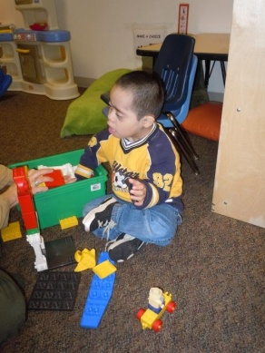
BLOCKS
During BLOCKS we can encourage:
Functional Play
Creating and Identifying Patterns
Sharing
Experimenting with Height and Balance Counting Designing and testing Ideas
Cooperation
Leaning to respect others work

During BLOCK and Structure Play we can remember:
Teachers can help children organize and express their ideas
Encourage experimentation
Introduce materials from other interest areas (toys, study related ideas)
This is a great time to practice problem solving and perseverance.
Skill Areas:
Encourage exploration with patterns, relationships, and designs
Promote the use of block structures as settings for dramatic play
Promote scientific exploration by providing a variety of materials including balance scales, natural items, mirrors, plastic or wooden animals

