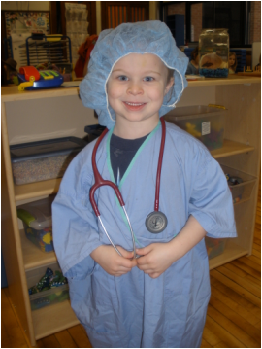
DRAMATIC PLAY
During Dramatic Play we can encourage:
Role Play Sequential Play
Imaginary Play Cooperative Play
Expanded Language Sense of Humor
Adaptive Self-Help Skills
During Dramatic Play we can remember:
The developmental order of play Solitary Parallel Cooperative
Follow the child’s lead Label their actions
Encourage peer interactions
Skill Areas:
Dramatic Play allows the child functional opportunities to practice dressing skills. Props in the Dramatic Play area connect functions of objects and counting with one to one correspondence. Children can relate to community workers.
Dramatic Play is dress rehearsal for life!

