How to complete Form 30a for Hearing Evaluation
(To access the form, click at the top of the page)
Enable Editing
The areas that need to be completed are:
- Date: (use the date you are completing the form)
- ESD Program: After EI/ECSE enter the name of your Site or County
- Service Request Description: Enter the child’s name under “Hearing Evaluation based on two failed hearing screenings”
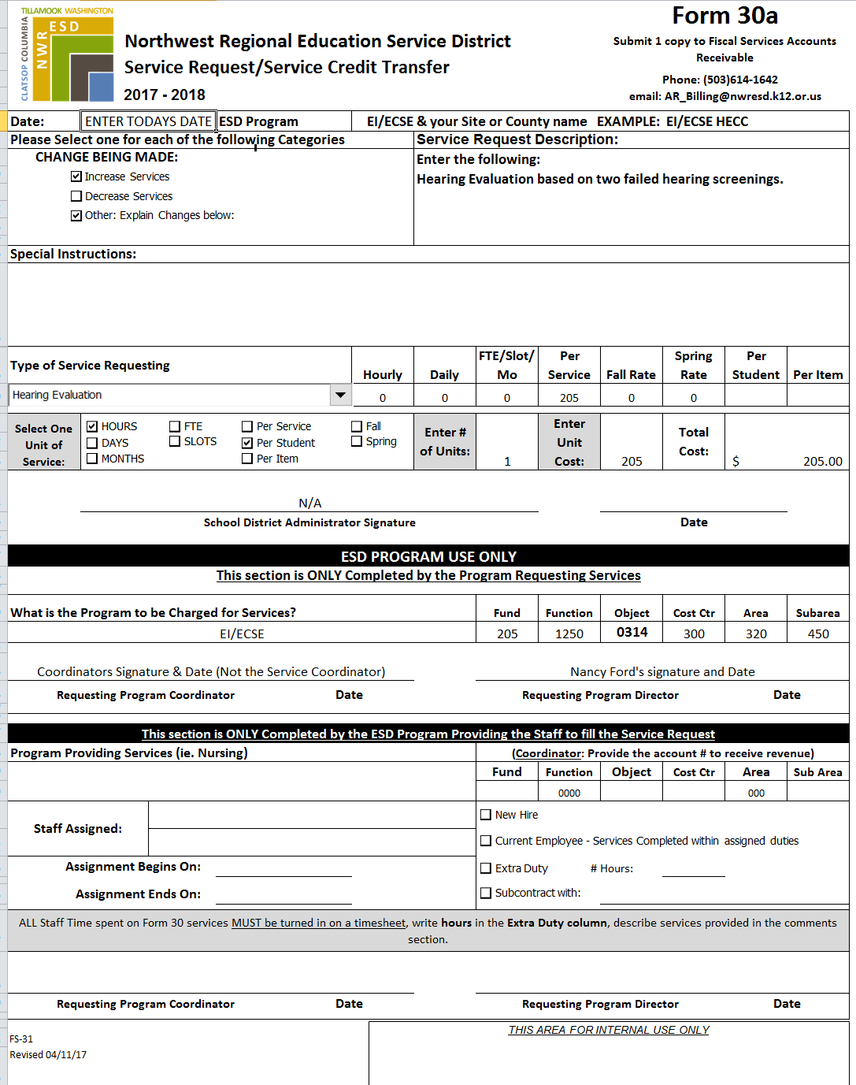
- Sign and Date the form in the “ESD Program Use Only” area
4
3
2
1
Enter child’s name here

