Linguava Web Scheduling
Linguava would like us to use web-based scheduling as the primary option, as it helps with accuracy and efficiency. This is a guide on how to communicate important information using their request form.
Please note: the website will automatically log you out after 10 minutes of inactivity. This is a HIPPA-compliant security measure and cannot be changed.
How/where to add information:
- Appt Date and Appt Time (self-explanatory). If you need the interpreter to come early to help family with paperwork, etc., enter the time you want the interpreter to arrive.
- 1st Language is the primary language requested for interpreting. There are times when a family speaks multiple languages, or a dialect of a language. If known, you can add a 2nd Language to help Linguava find the best interpreter fit for the family.
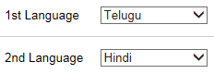
- Patient/Client and Patient/Client DOB is child’s name and birthdate.
- Preference for gender – some cultures/families request specific genders. If either gender is selected, and Linguava cannot fill appointment with requested gender, they will call you before scheduling the opposite gender.
- Patient/Client Phone is parent’s phone number
- Appt Address – this will auto-fill to your site’s location. However, if the appointment will be at a different location, you can type in the address in the larger box. It’s okay if it’s different than the selection from the drop down menu above – the appointment will be at the address in the box.
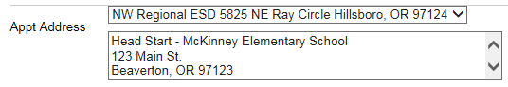
- Department – this is the type of appointment or the department of the site. Examples: Early Intervention evaluation, home visit, toddler class, or teacher’s name if IFSP meeting, etc.
- Insurance Co. and Member ID/Claim # are not applicable to us and are left blank.
- Facility phone is for the site location. If this is a home visit or a preschool visit, and the EI staff has a cell phone you are authorized to share, add it to the Contact field.
- Reference is a field where you can add important information to share with the interpreter, such as apartment complex name, parent’s name, what to bring to appointment, etc. This box does not expand when typing, but you can write longer notes. For example: “Mom's name is Carmen and she is a fluent English speaker. Interpreter is for child's testing. Please remind parent to bring completed intake packet.”
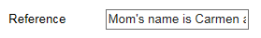
- Comments is a field that you can add important information that is NOT shared with the interpreter. This is where you can request specific interpreters, request a call back for confirmation, or add additional notes.

To create a new appointment for a child that’s already in their database:
- From the dropdown menu on right, click All Appointments. Enter the child’s name and search.
- A list of prior appointments for this child will appear. Click on one of the past order numbers. You will not be able to edit this appointment and all boxes will be gray. Scroll to the bottom of the page and click COPY.
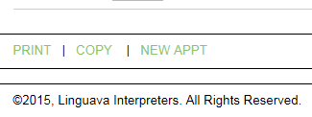
- A new appointment screen will now appear with the language, child’s name, birthdate and phone number pre-filled. Fill in the information related to the new appointment as usual and Save. A new order number will be generated.

