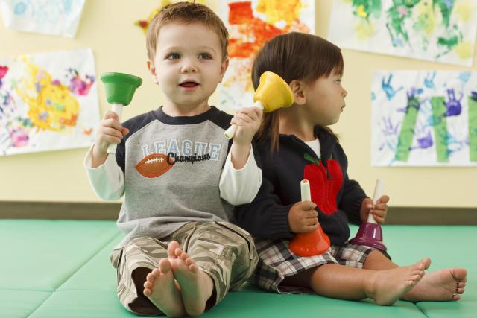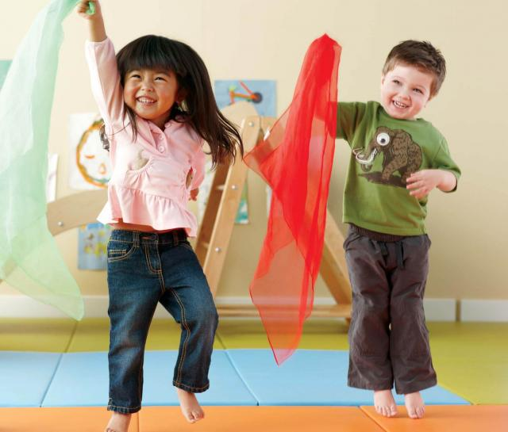MUSIC &

MOVEMENT

**During MUSIC & MOVEMENT we can encourage:**

Exploration of Space

Exploring Body Movements & Body Awareness

Experimenting with Music & Movement Materials

Listening & Imitation

Imagination

**During MUSIC & MOVEMENT we can remember:**

Some children just like to watch, listen & feel the rhythm

To model how to be silly, dance and play instruments

Respond to what children are doing by asking questions, following their lead, encouraging exploration and imitating their actions and movements

**Skill Areas:**

Narrate what they are doing

Ask children to move their body in new ways

Present opportunities for cooperative activities

Use body movements and music to count, problem solve and introduce new vocabulary

Use technology to find and create music