Toys & Games
Encourage and Model:
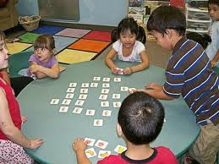
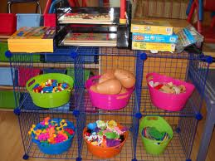
Sharing
Turn Taking
Cooperative Play
Negotiation
Problem Solving

Remember:
Talk about what you are doing
(label, explain, describe, compare, contrast)

Demonstrate targeted skills
(sorting, matching, counting, patterning, classifying)

Present new vocabulary and concepts
(i.e. size, color, location, and sequence)

Scaffold peer interactions
(encourage, model and support)

Ask open ended questions!!

